**LAPORAN ACTIVITY**

Mata Praktikum : Perancangan Analisis Algoritma

Kelas : 3IA24

Praktikum ke- : 3

Tanggal : 3 November 2023

Materi : Algoritma Brute Force

NPM : 50421704

Nama : Juan Samuel Christopher

Ketua Asisten : Sherina Permata

Nama Asisten :

Paraf Asisten :

Jumlah Lembar : 3



**LABORATORIUM TEKNIK INFORMATIKA**

**UNIVERSITAS GUNADARMA**

**2023**

**SOAL**

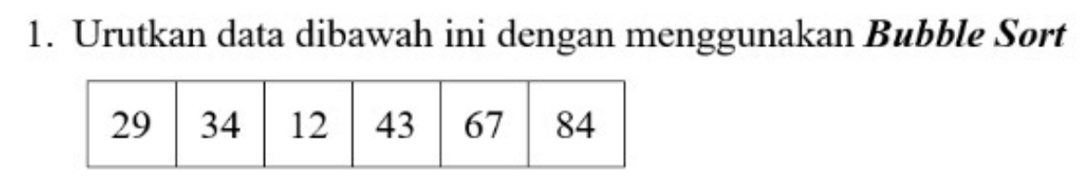

**Jawab :**

Iterasi 1 = 34 (ada 1 pertukaran)

|  |  |  |  |  |  |  |
| --- | --- | --- | --- | --- | --- | --- |
|  | 29 | 34 | 12 | 43 | 67 | 84 |
|  | 29 | 12 | 34 | 43 | 67 | 84 |
|  |

Iterasi 2 = 29 (ada 1 pertukaran)

|  |  |  |  |  |  |  |
| --- | --- | --- | --- | --- | --- | --- |
|  | 29 | 12 | 34 | 43 | 67 | 84 |
|  | 12 | 29 | 34 | 43 | 67 | 84 |

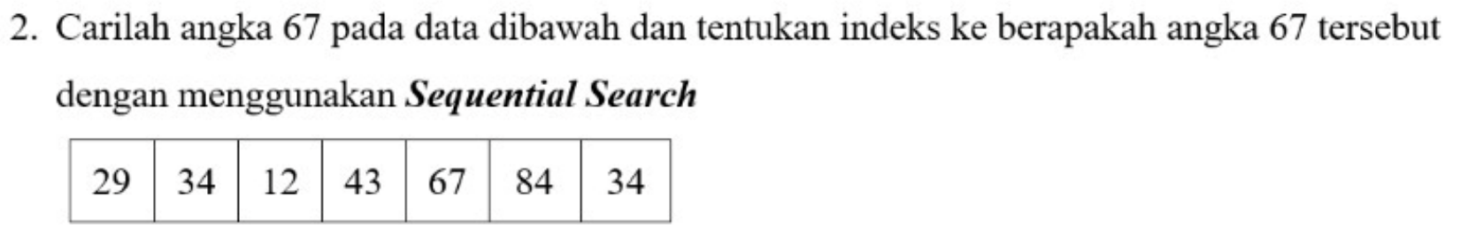

Jawab :

|  |  |  |  |  |  |  |
| --- | --- | --- | --- | --- | --- | --- |
| **29** | **34** | **12** | **43** | **67** | **84** | **34** |

**67**

|  |  |  |  |  |  |  |
| --- | --- | --- | --- | --- | --- | --- |
| **29** | **34** | **12** | **43** | **67** | **84** | **34** |

**67**

|  |  |  |  |  |  |  |
| --- | --- | --- | --- | --- | --- | --- |
| **29** | **34** | **12** | **43** | **67** | **84** | **34** |

**67**

|  |  |  |  |  |  |  |
| --- | --- | --- | --- | --- | --- | --- |
| **29** | **34** | **12** | **43** | **67** | **84** | **34** |

**67**

|  |  |  |  |  |  |  |
| --- | --- | --- | --- | --- | --- | --- |
| **29** | **34** | **12** | **43** | **67** | **84** | **34** |

67 *found*

Ditemukan pada indeks ke-5

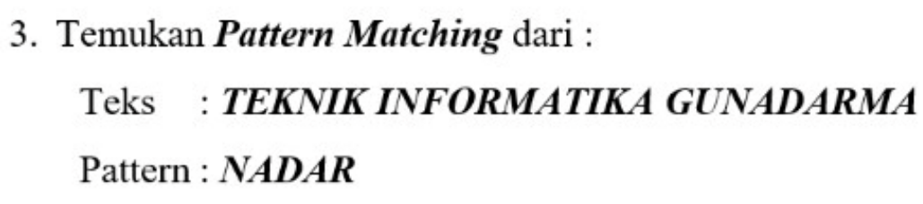

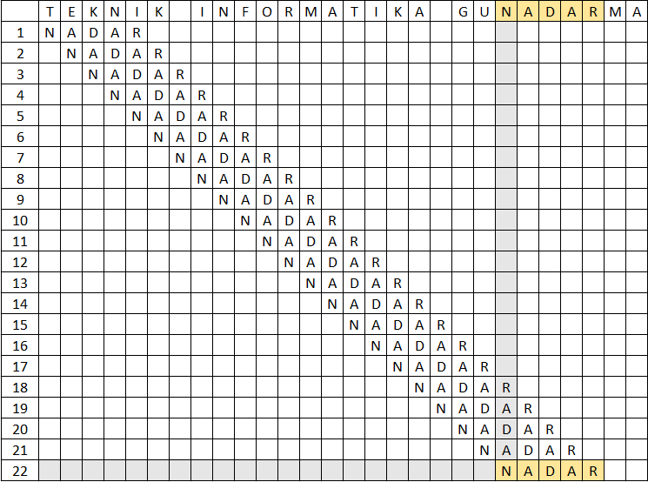

Ditemukan pada character ke - 22